**What is a ‘Jubilee Year’?**From the book of Leviticus, a ‘jubilee year’ is a year-long celebration that takes place every 25 or 50 years. The church celebrates jubilees to encourage everyone to open their hearts and be renewed in the mercy and love of Jesus.

Here at Mother Cabrini Shrine, we are very blessed to have been designated as a holy site for this Jubilee Year of Hope. With this designation comes the opportunity to receive a plenary indulgence, a blessing given by the Church that alleviates the temporal punishment of sin.

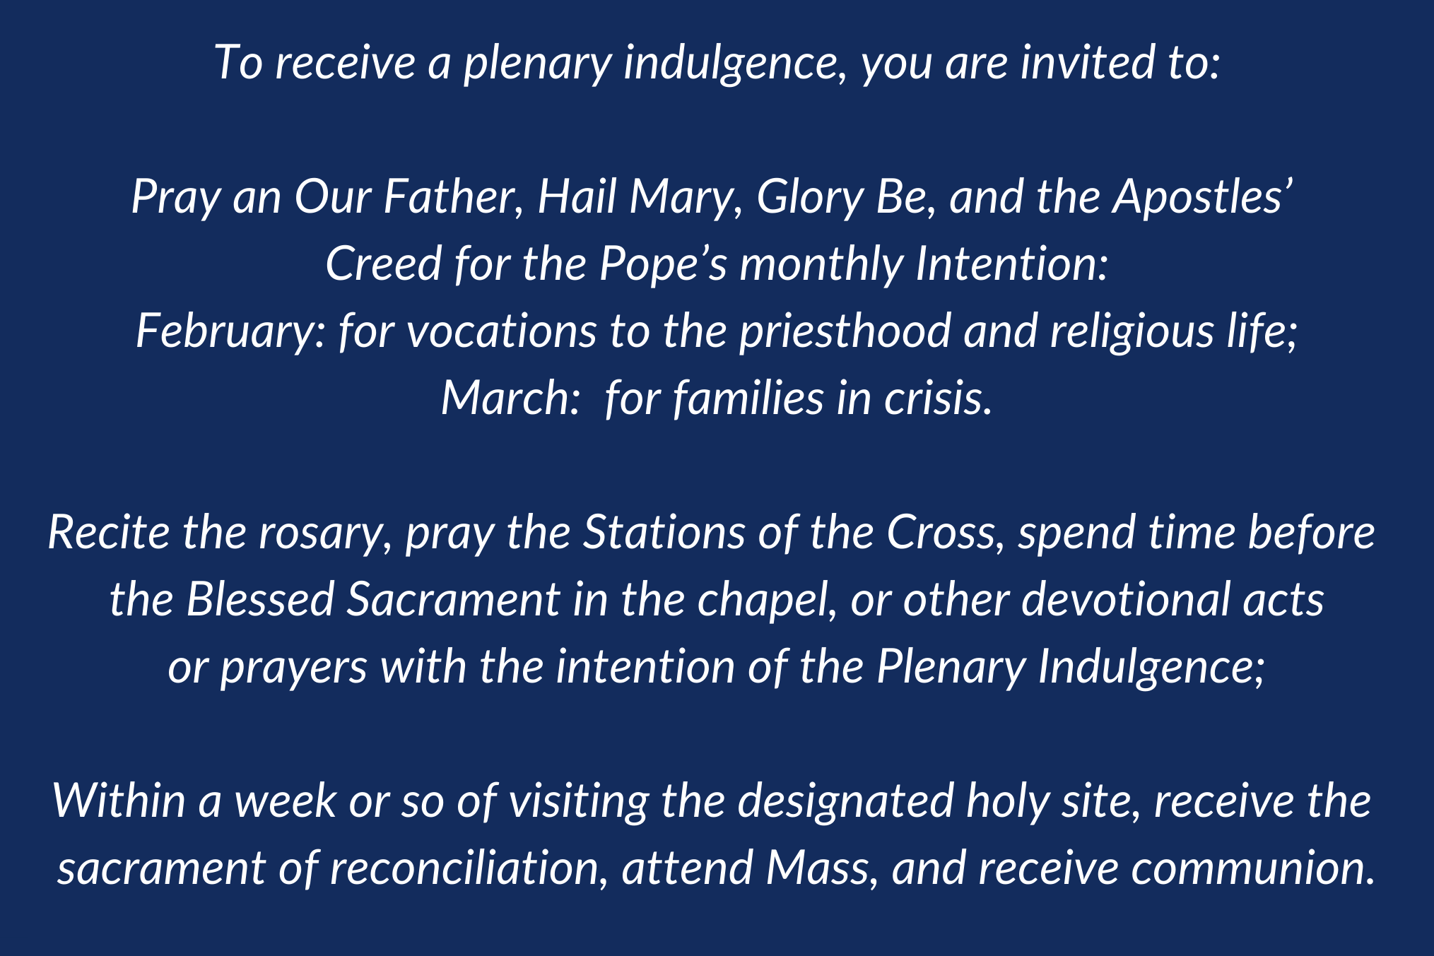

In addition, as a special request of Pope Francis, you are invited to do some act of charity, particularly for the poor, the immigrant, and those forgotten or ignored. Perhaps you can volunteer at a soup kitchen, participate in a clothing drive, or even a simple act of kindness through a smile or acknowledging someone you encounter.

If you’ve visited the Shrine recently, you may notice that a Pilgrim cross has been placed at the entrance of our chapel. The cross is a sign of our hope in the transforming love of God. Next to the pilgrim cross is water, a symbol of our baptism. Our baptism is rooted in the life and mysteries of Jesus Christ. Throughout this Jubilee Year of Hope, we will continue to provide opportunities and information for us all to be pilgrims of hope.



JUBILEE YEAR OF HOPE PRAYER

Mother Cabrini Shrine



Heart of Jesus, Lover of my soul,

Send Your Advocate, the Holy Spirit,

to reawaken in us the gift of Hope for the coming of your kingdom.

As we proclaim this Jubilee Year,

may we be reminded of St. Paul’s words:

“Hope does not disappoint.”

Despite not knowing what the future may bring,

May hope dwell in the heart of each person

as the desire and expectation of good things to come.

When I feel helpless or weak,

when I doubt or lack trust,

when my heart is distracted from you,

cleanse me from within, that I may be fit to love,

courageous to suffer, and steady to persevere.

St. Frances Xavier Cabrini, Pilgrim of Hope,

intercede for me,

and all the faithful, seeking a new life of hope.

Most Sacred Heart of Jesus,

you are my hope;

I trust in you.

Amen.

